**DST Jul 29 recommendations**

Termination

Issue: we need to account for growers that would normally spray burn-down herbicide (without cover crops), but may change the herbicides used or rates when cover crops are planted.

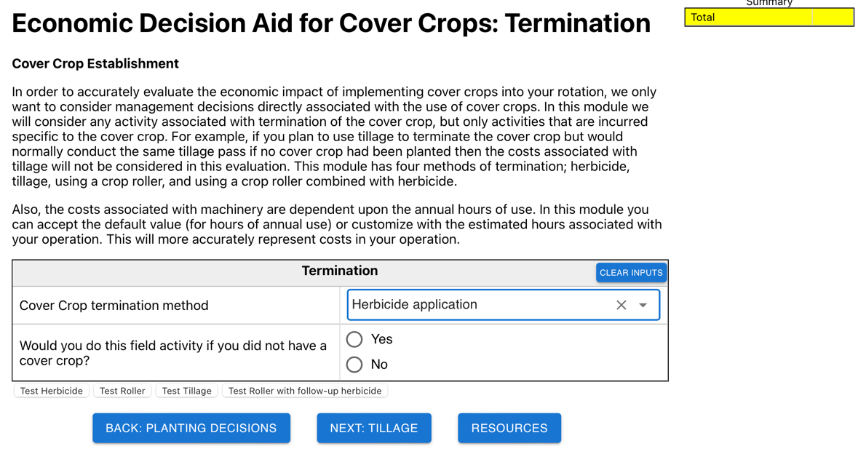

Currently, if the user selects “yes” on the 2nd question they will automatically move to the tillage module. We need to add additional questions before moving the user to the next module.

Recommendation:

* If the user selects “yes” to the question, “Would you do this field activity if you did not have a cover crop?”, then
  + Provide the following text:
    - “Even if you would normally spray a burn-down application, you may elect to add/remove an herbicide or change the rate applied. For example, if clover is part of your cover crop mix you may wish to include 2, 4-D to help sure adequate termination. Alternatively, some growers have found that use of cover crops (e.g. cereal rye which has an allelopathic effect) allows them to reduce herbicides used in their tank mix.”
  + Q: “Will you change the herbicides use in your tank mix?
    - If no, move to tillage modules
    - If yes,
      * Create an input table similar to the following



Note:

* Obviously, the additional herbicides will show up as costs in your summary table and the herbicides not used will show up as savings.
* Although most users are not going to add multiple herbicides or forgo multiple herbicides, can you program so they can enter more than one product?